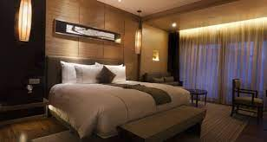

**Johnston Country House and Hotel**

Meath further inland but still close to Dublin is Meath. Johnstown house hotel and spa is a unique modern development outside Enfield in Co. Meath. It opened this Augusts and is located just 30 minutes from the outskirts of Dublin, on the n4. The hotel is developed around a 1750,s Victorian estate house. Set 80 acres of stunning parkland landscape wit riverside walks, Johnstown house spa will offer 125 luxuriously appointed and 17 deluxe suites, a choice of restaurants back projection and a selection of bars and lounger areas.

A wide range of conference facilities are available: the conference centre caters 600 delegates and a selection of nine boardrooms are available for smaller meetings. The conference suites incorporate and latest state of art audio-visual equipment, including and video conferencing and are operated from a single podium point, which controls lighting and sound technologies, Barco reality 6400 with black protection and zoom lens, video and T V2